**EXP NO: 10**

**DATE: 14-04-24**

**Aim:**

Create a simple cloud software application for online super market using any Cloud Service Provider to demonstrate SaaS with the template of customer name, address, phone, email, items, quantity etc. with the item classification form.

**Implementation:**

**1. Go to Zoho.com and login/signup**

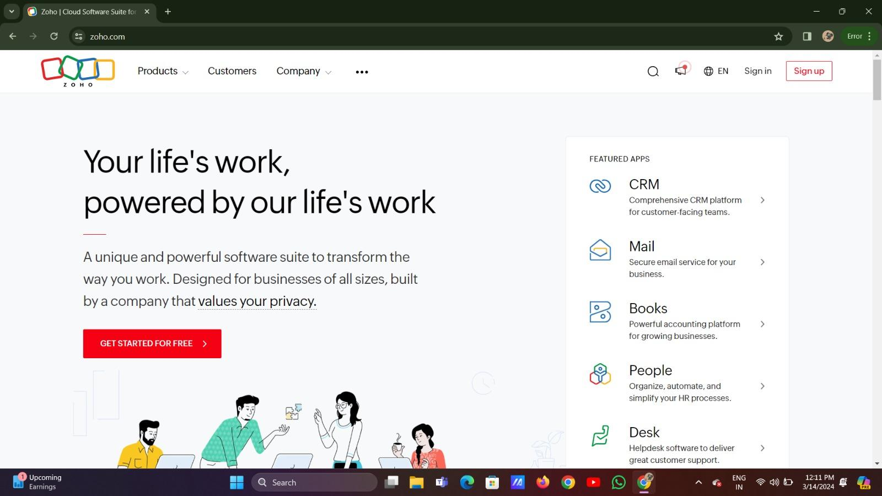

**2. Go to Creator**

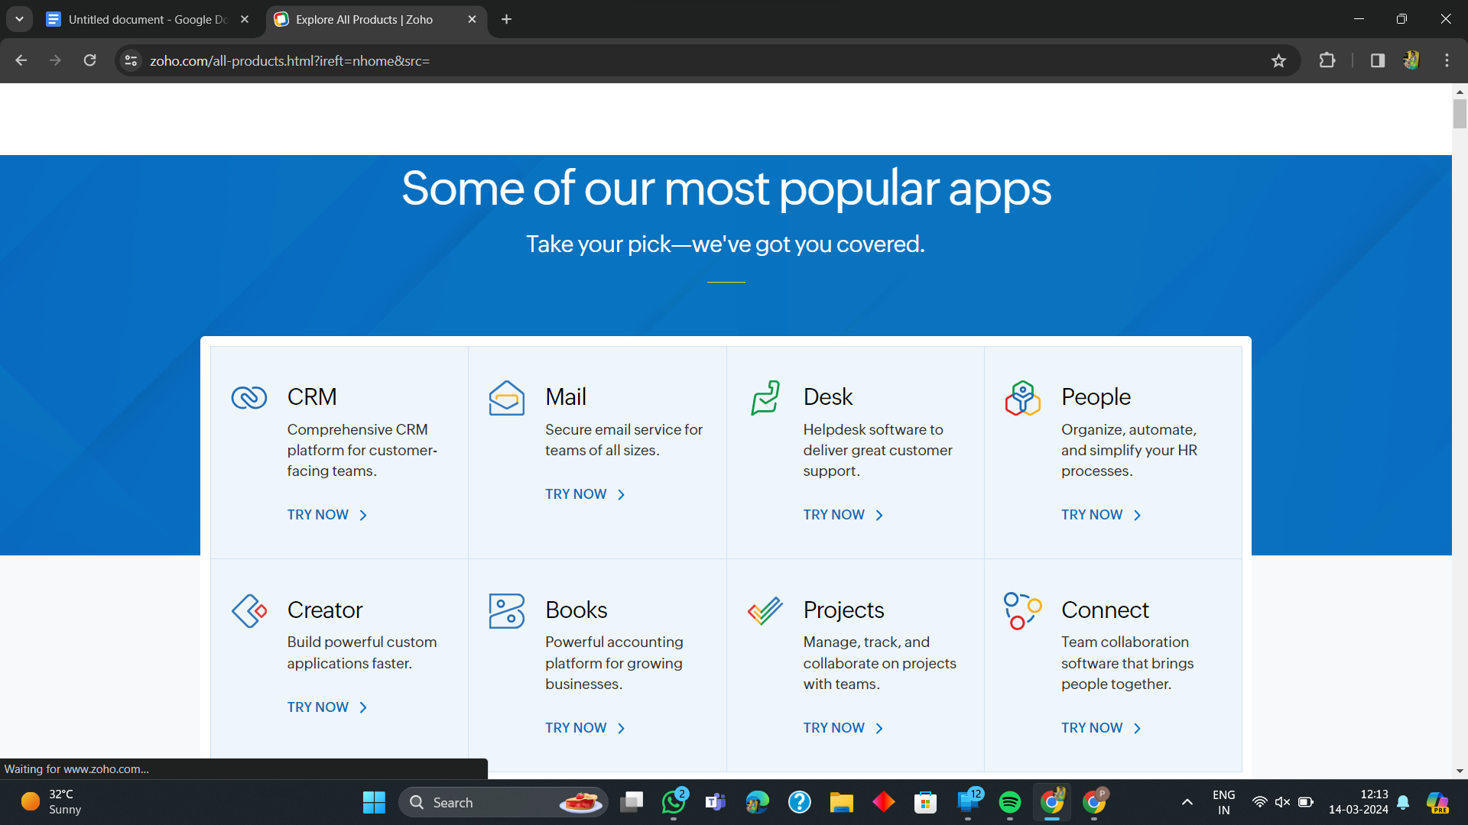

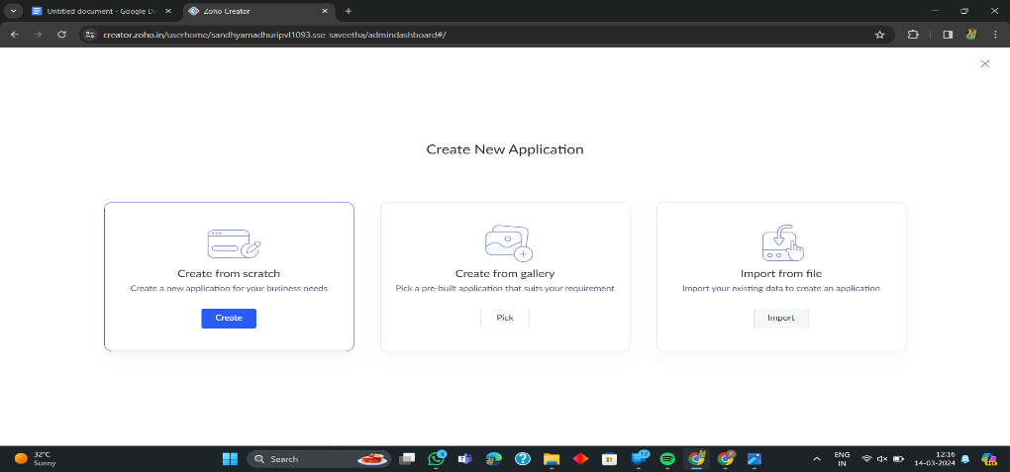**3. Create A New Application**

**4. Given Application Name**

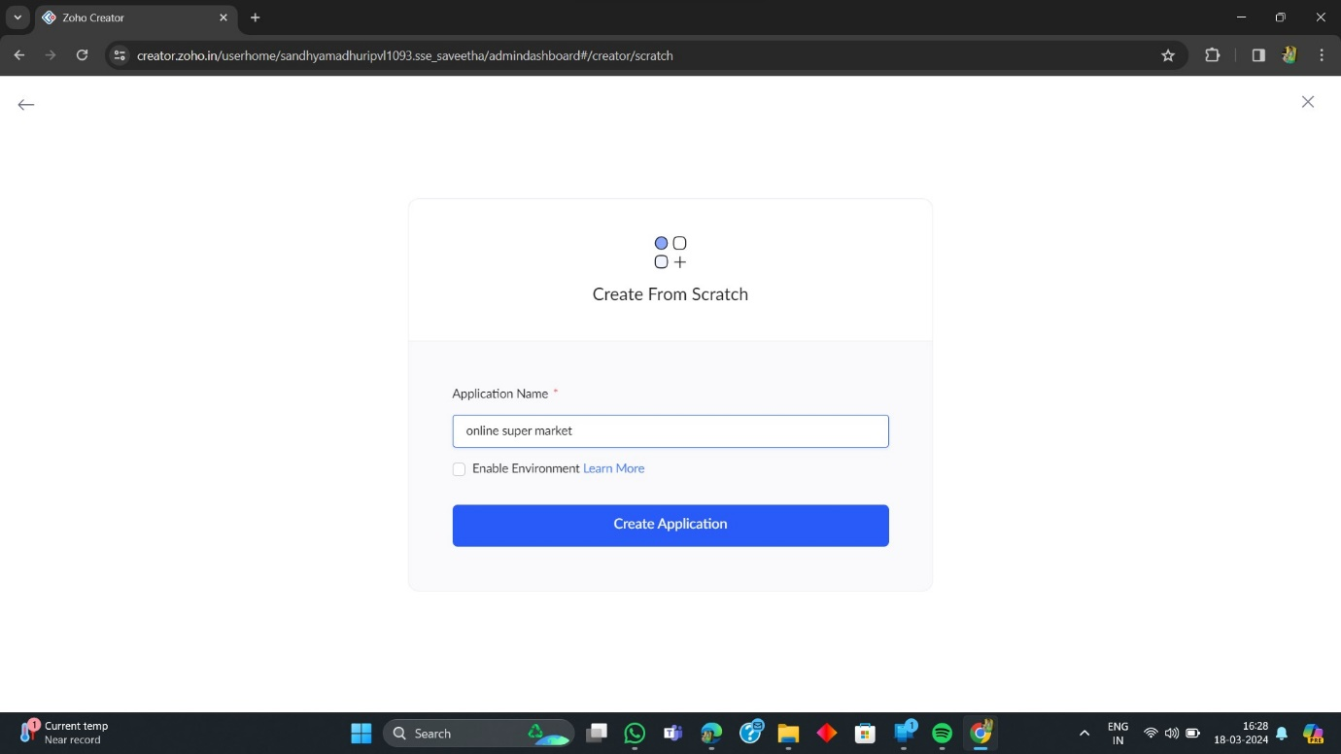

**5. Create New Form**

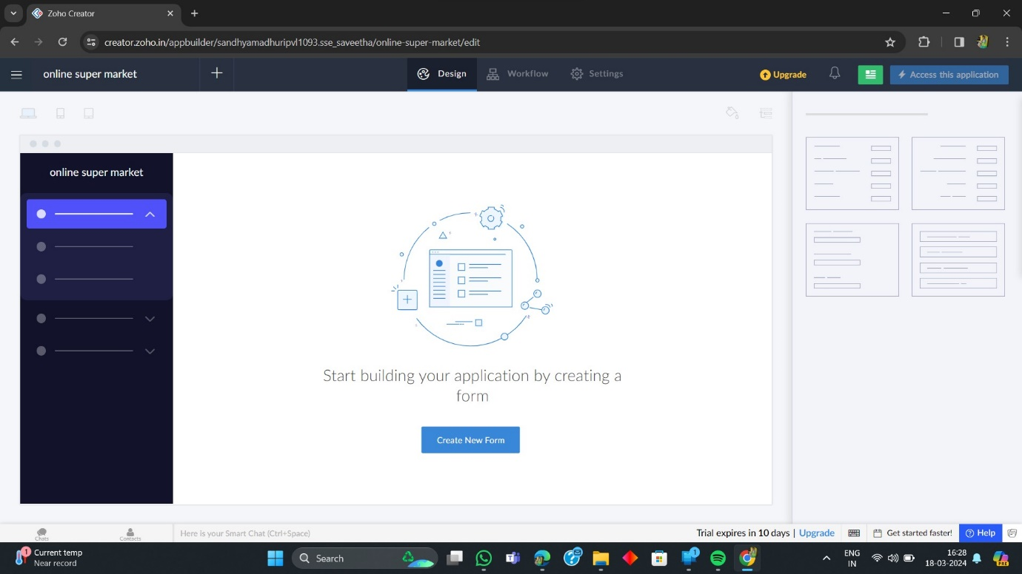

**6. Select Form and Give Name**

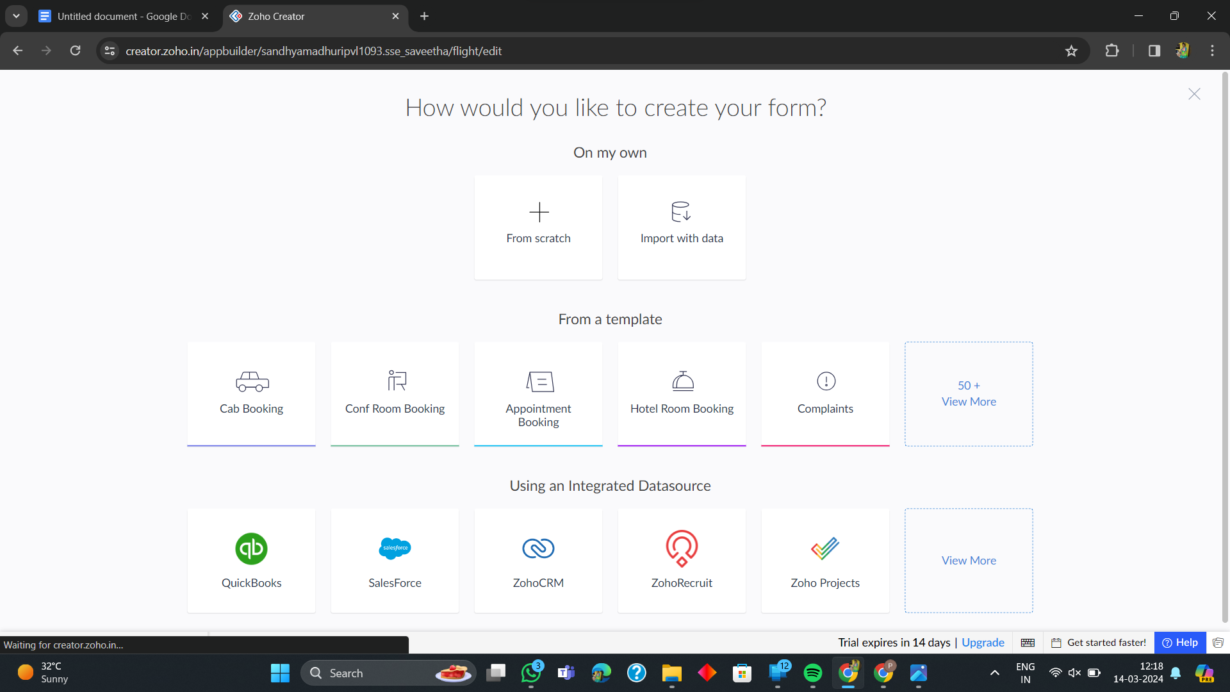

**7. Create from scratch**

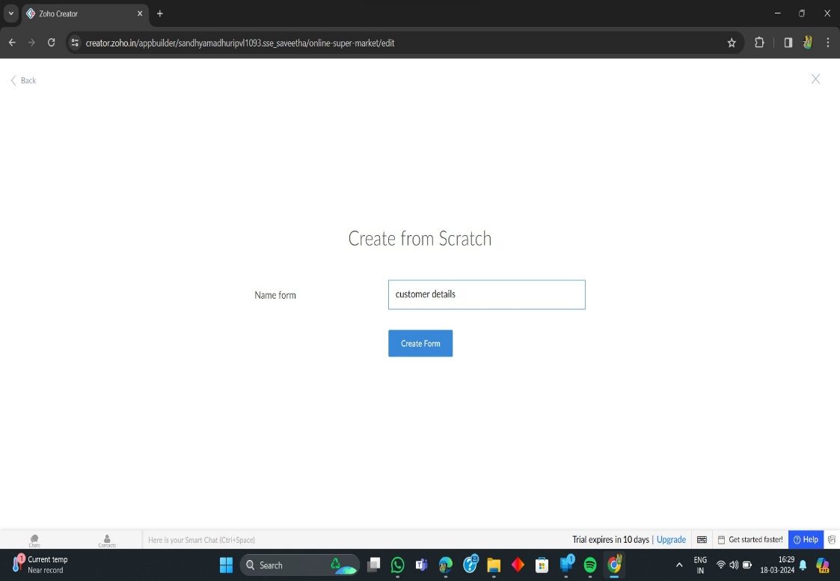

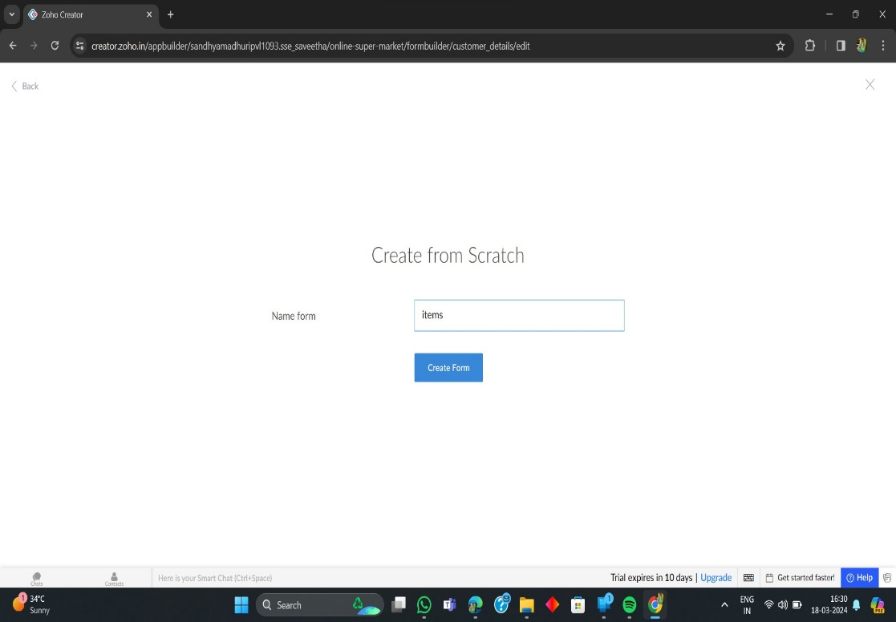

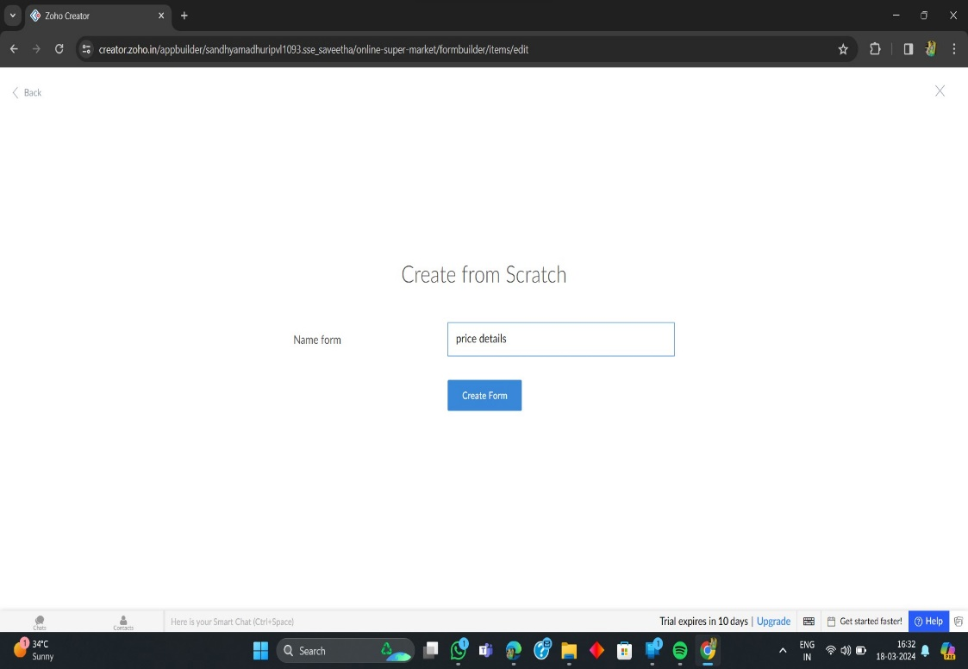

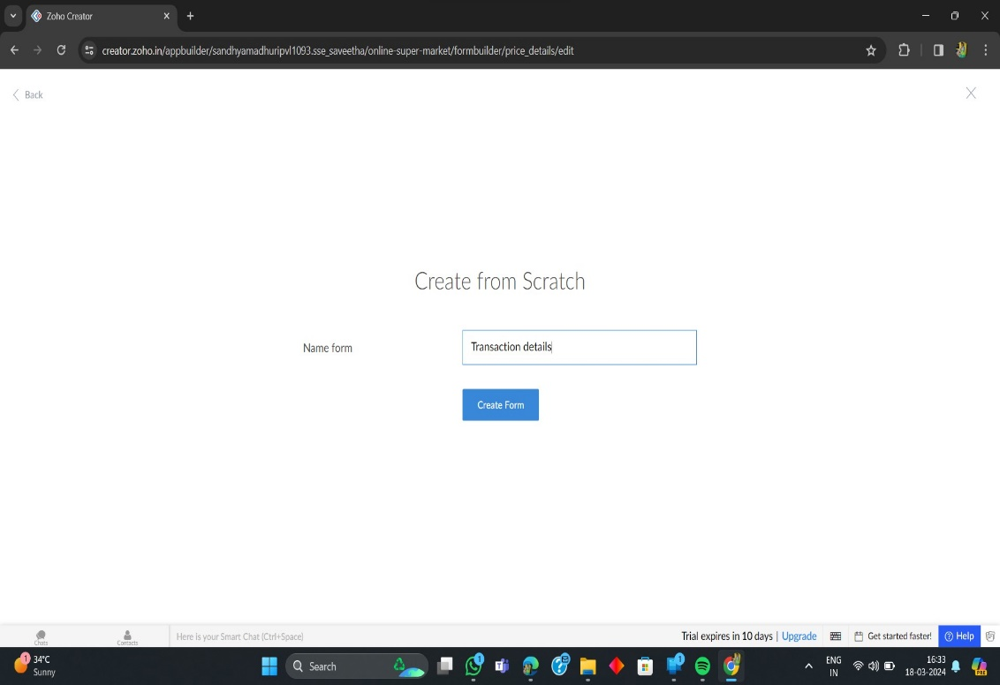

**8. The Software Has been created**

